Tyson Martin

COM-391

Prof. Estey

Milestone 2

03/16/2025

**Project Proposal**

**(Verse App)**

Tyson Martin

## **1. Introduction**

**VerseVault** is a web application that allows users to **save, organize, and share Bible verses**. Users can tag verses with themes (some examples would be: "Faith," "Hope," or "Encouragement"), add personal notes, and search for verses easily.

### **Target Audience**

* Individuals studying the Bible
* Church groups & ministries
* Pastors and preachers
* Christian communities online

### **Technology Stack**

* **Backend:** Node.js, Express.js, MySQL
* **Frontend:** Angular & React (two separate implementations)

## **2. Functionality Requirements**

### **MVP (Minimum Viable Product) Features**

1. **Bible Verse Management:**
   * *As a user, I want to save Bible verses, so I can reference them later.*
   * *As a user, I want to organize my saved verses into categories (e.g., Faith, Strength), so I can find them easily.*
   * *As a user, I want to update my saved verses, so I can add personal notes or reflections.*
   * *As a user, I want to delete saved verses that I no longer need.*
2. **User Authentication:**
   * *As a user, I want to register and log in, so my saved verses are private and secure.*
3. **Search & Filter:**
   * *As a user, I want to search for specific Bible verses by keyword or category.*
   * *As a user, I want to filter verses by category or book of the Bible.*
4. **Sharing & Community Interaction:**
   * *As a user, I want to share a Bible verse with others via a public link.*
   * *As a user, I want to "like" or save a verse shared by someone else.*

## **3. Initial Database Design**

The database will include:

* **Users** (id, name, email, password)
* **Verses** (id, user_id, book, chapter, verse_number, text, category, notes)
* **Categories** (id, name)
* **SharedVerses** (id, user_id, verse_id, share_link)

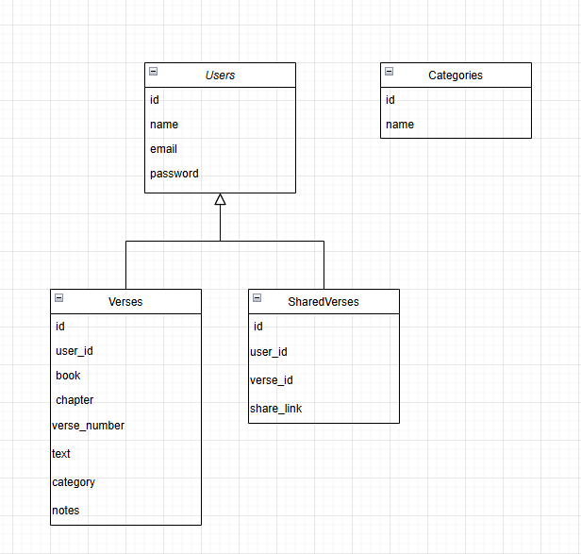

## **4. Initial UI Sitemap**

Logical navigation of the app:

* **Home** (List of all saved verses)
* **Login/Register**
* **My Verses** (CRUD actions)
* **Categories** (Filter Bible verses)
* **Search Page**
* **Shared Verses** (Publicly accessible verses)

## **5. Initial UI Wireframes**

Low-fidelity wireframes for the main pages:

* **Login/Register Page**
* **Home (List of Saved Verses)**
* **Bible Verse Details**
* **Create/Edit Verse Page**
* **Search Page**

## **6. Initial UML Class Diagram**

A UML diagram illustrating the backend architecture:

* **User Class** (Handles authentication and user data)
* **Verse Class** (CRUD operations for verses)
* **Category Class** (Stores predefined categories)
* **SharedVerse Class** (Manages shared verses)

—> This can be drawn using **Lucidchart, draw.io, or PlantUML**.

## **7. Risks & Challenges**

* **Database Complexity:** Ensuring verses are properly categorized and searchable.
* **Security:** Protecting user data and shared content.
* **User Experience:** Designing a clean UI for browsing verses efficiently.
* **Deployment:** Hosting the MySQL database and Express API online.